Charity page

As per client requirement we have three kind of users

* Super Admin
* Admin
* Donor

There are two use of this page

1. For Admin:- when a user register as charity Admin, he/she can edit, update or delete general information regarding charity.

User can also delete the charity but data will be still store in the database

Privilege of admin can only be given super admin from the database.

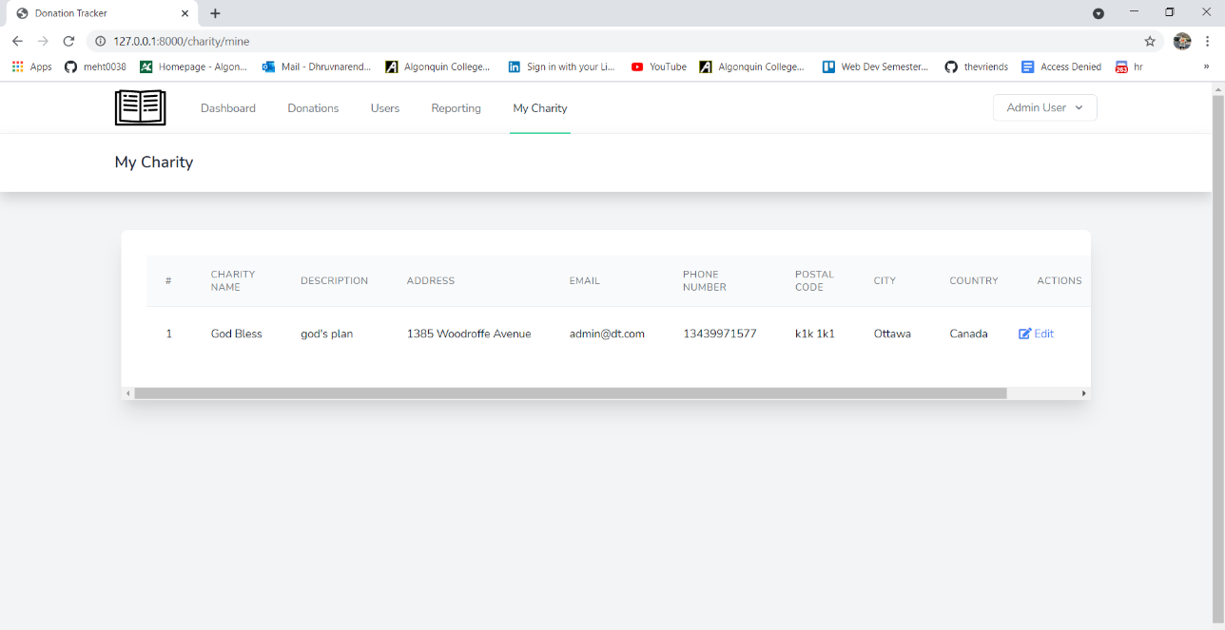

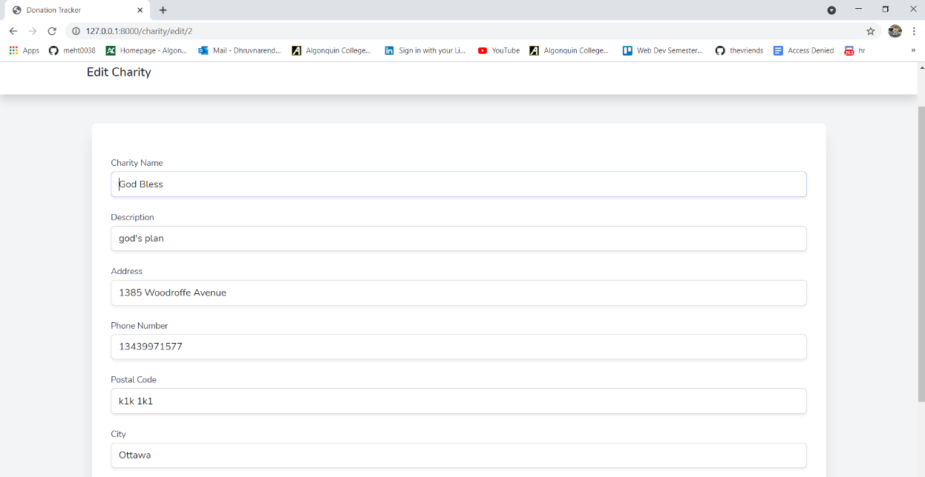

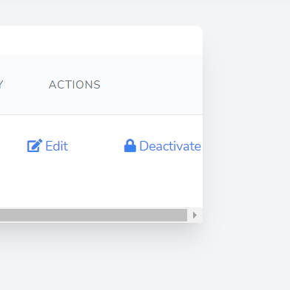

1. For Super Admin:- There only one super admin who will manage the whole web Application.

Job of super admin is to give permission to create charity Admin.

Super Admin have access to all the charities but Super Admin does not have privilege to edit the Charity Admin Details.

Super Admin can delete the charity.

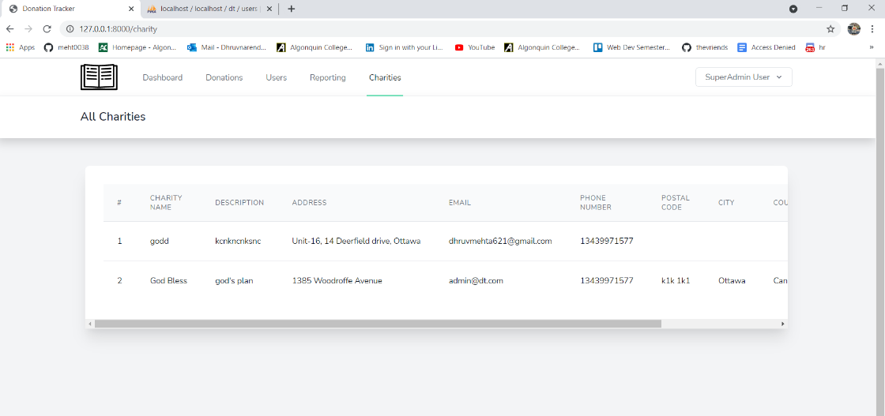

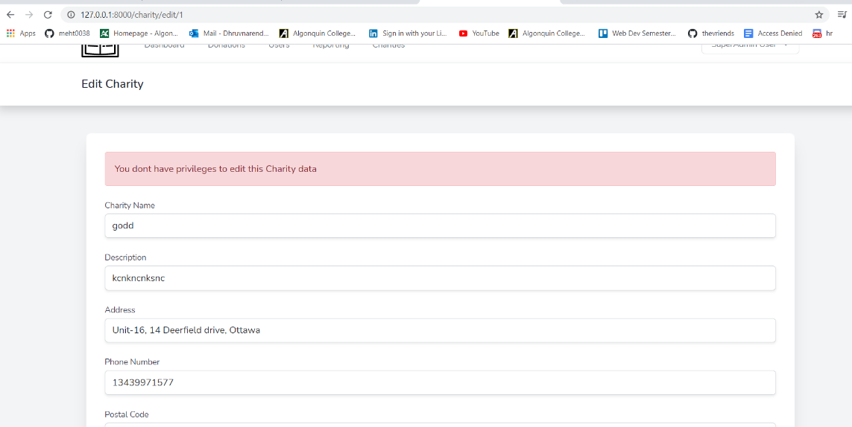

# Old Requirements

# Users and their roles:

1. Super Admin:
   1. This is a person who will manage entire application.
   2. The major task of this user will be
      1. Create a church
      2. Create an Admin user.
      3. Can perform every action done by other User (May not delivered considering time crunch).

(Do we have more than one admin for each church?)

1. Admin:
   1. This is a person who will manage all the categories, charities and volunteer related to church.
   2. He/she will add/update/delete/view charities.
   3. He/she will add/update/delete/view categories associated with charities.
   4. He/she will add/update/delete/view volunteer associated with the charities.
   5. Can perform every action done by other volunteer. (May not delivered considering time crunch).
   6. Generate tax report (May not delivered considering time crunch).
2. Volunteer:
   1. Add donations.
   2. Can Update/View donation add by themselves.

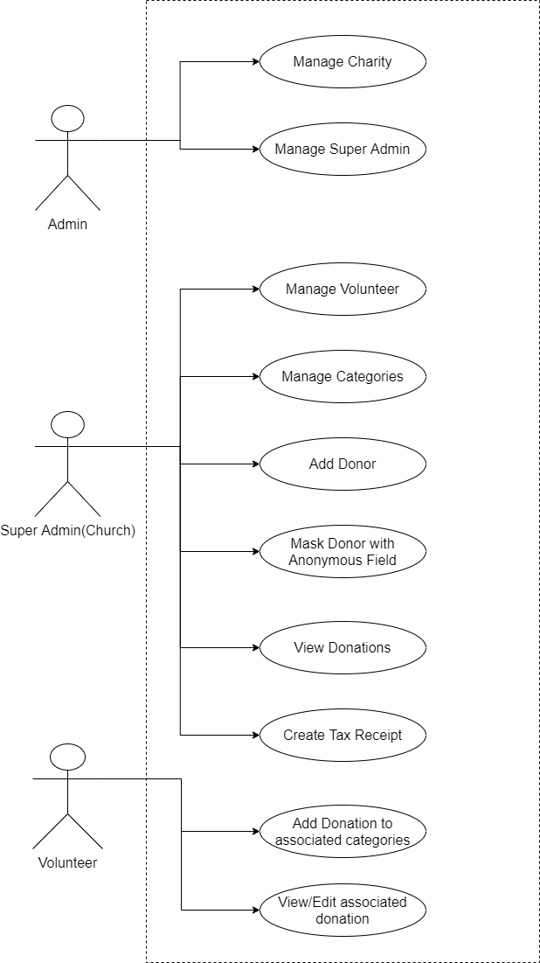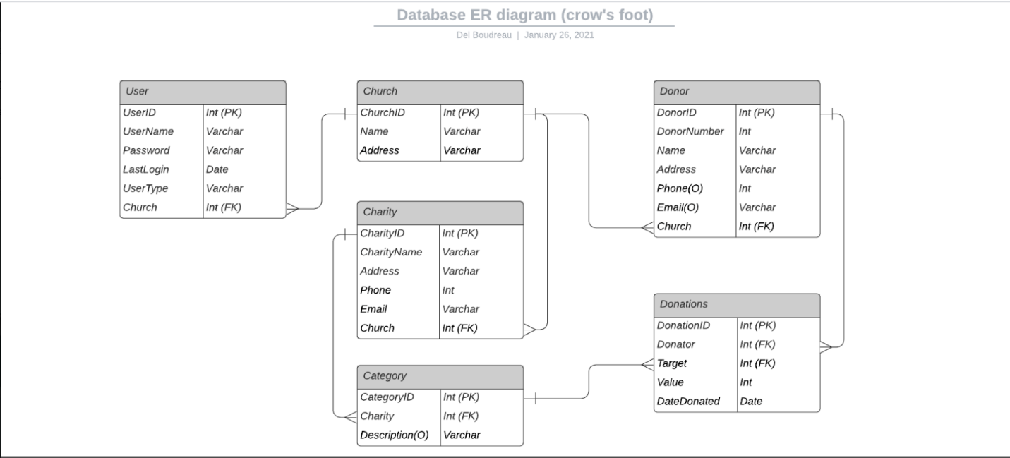

Old

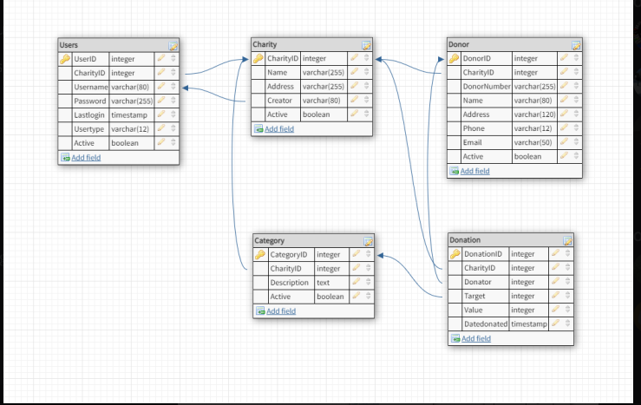

New

